Kristal Machado

Lab 14

Respiratory Physiology

14-C: Portable spirometry

**Purpose:**

The movement of air in and out of the lungs is essential to maintain the important process of cellular respiration, the oxidation of nutrient molecules. We will be measuring the total air capacity.

**Procedure:**

1. Open the gray plastic box on your lab desk that says “BASLINE Lung Capacity Spirometer” on the lid. Inside the lid of the box is a white paper that has specific instructions, please read the whole inside page with “how to us”.
2. Insert the clear plastic mouthpiece of the “Windmill-Type” spirometer and make sure the measurement indicator is at the zero position before beginning.
3. Make sure you only exhale into the spirometer, DO NOT inhale from it.
4. After exhaling, record the measurement from the spirometer. Be sure to place your used plastic mouthpiece in the correct tub after use.
5. Calculate your predicted vital capacity from the nomograms available in the lab. Using a straightedge, make a line matching your height and age to the vital capacity prediction. Note that the VC is in liters where's other measurements have been taken in milliliters.
6. Compare the values obtained from the portable spirometer, the predicted values from the nomograms, and the values obtained from Koko spirometer, if available can your account from any differences?

**Results:**

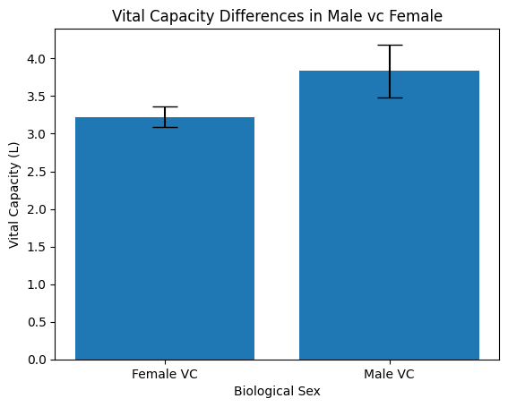

**Discussion:**

We did a comparison male/ female vital capacity difference, and I figured male numbers would be a lot higher than the female. As I predictions male numbers were significant higher.

**Conclusion:**

In conclusion the movement of air in and out of the lungs is essential to maintain the important process of cellular respiration. Using the spirometer, we were able to see the volumes of air involved in pulmonary ventilation.